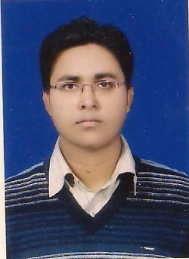
Resume

TAJUL ARFIN
Ph- 08877881130,09934675586
Email Id- amjadrfin@gmail.com

Objective
To have a challenging career in an organization, which gives me a chance to update my knowledge, skills and be a part of team that excel in work towards the growth of organization and give me a job satisfaction.

EDUCATIONAL QUALIFICATION
10th
Passed from B.S.E.B Patna in 1998.

12th
Passed from B.I.E.C Patna in 2000.

TECHNICAL QUALIFICATION

Diploma in industrial safety management from N.I.L.E.M Chennai in 2007.

Diploma in computer application form APTECH computer education Jamshedpur in 2004.

OTHER QUALIFICATION

Computer Skills * MS-Word, Ms-Excel, Ms-Power Point & Net surfing.

EXTRA CURRICULUM ACTIVITY

Strengths
* Straight Forward, Problem Solving Attitudes, Enjoys Responsibilities.

Hobbies
* Voluntary work for society * Reading & * Swimming.

PERSONAL DETAILS
Gender Male
Languages Known English, Urdu, Hindi.
Marital Status Unmarried
State Bihar
Nationality Indian
Permanent Address s/o S.M Najmul Arfin
Post- Lakhminia, Distt- Begusarai.
Ph- 09934730383.
DECLARATION

I hereby certify that the particular given here in are true to the best of my knowledge and
belief.

Date Signature

